Notes: Up to two players can play the game. The top left and top right knights are the players while the green ogres are the enemies. All player movement, unless stated, is controlled either by keyboard or controller. When shooting black shots are special bullets that slow you down while green/red shots hurt you.

**Videos:**

1. AI movement

Grid of map was created at start of game to find all possible points that can be traversed. Each enemy then uses A* algorithm to find best route between current position and the desired location. The red line shows the path that was found.

1. AI shooting

Each enemy has their own target they are aiming at. The target here will be the player.

1. AI hiding

It tries to find a position on the map where neither player has direct line of sight to them. (Flow diagram 2)

1. AI flanking

A line between them and target is created. Halfway on the line, a perpendicular line is constructed and a position a certain distance away from line on perpendicular line is selected to use as the flanking point. AI movement is then used to get to the point and then towards the target. Both members in group are given separate flanking directions.

1. AI swarm

All swarm members target the same enemy and will move towards them. When swarm members come close to each other, they will benefit by having increased shooting speed as well as a small health regeneration over time. When swarm member is hurt they will retreat into a hiding state. (Flow diagram 3)

1. AI together

The group members will start by trying to get close together. This can be seen at start of the video. Once together they will start trying to flank their target going in opposite directions. After a while the one group member is shot going into hiding state where they try to run away but still try to stay close to the other group member. This can be seen at the 20 second mark where one group member health has gone down to 10. (Flow diagram 4)

1. AI player

The player controller characters can be controlled by the computer. The player will use a modified version of the flanking path that resulted in always trying to circle around the target. A line between them and target is created. A perpendicular line is constructed at the start of the line and a position a certain distance away from line on perpendicular line is selected to use as with direction to move. Using this algorithm every frame causes the player to walk in circles around the target. The player’s path is represented by the yellow line.

1. Player Auto aim

The enemies have the benefit of pin point accuracy while the player has to struggle with keyboard or controller. If the player is within a certain angle away from the direction the enemy is in, the player will automatically shoot directly at the enemy. This allows faster reactions and less worrying about small changes in aiming. The video shows the player always aiming directly to the right with no other directions being used.

**Flow Diagrams:**

1. Basic enemy

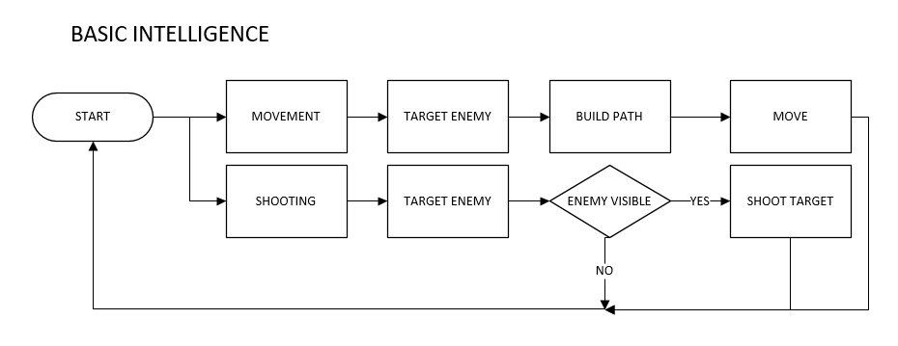AI movement (Video 1) and AI shooting (Video 2) is used by the basic enemy in this flowchart.

1. Hiding Enemy

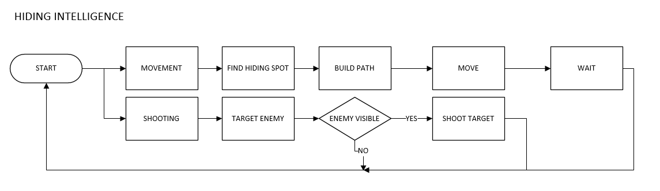Using AI movement (Video 1), AI shooting (Video 2) and AI hiding (Video 3) in this flowchart.

1. Swarm Enemy

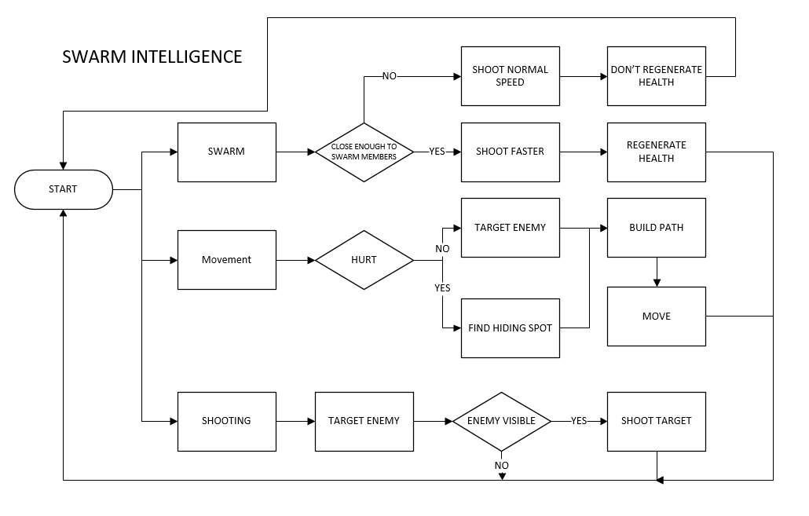Using AI movement (Video 1), AI shooting (Video 2), AI hiding (Video 3) and AI swarm (Video 5) in this flowchart.

1. Flanking Group Work Enemy

Using AI movement (Video 1), AI shooting (Video 2), AI hiding (Video 3) and AI together (Video 6) in this flowchart.

